**Spell Checker**

**Theory:**

**MRR (Mean Reciprocal Rank):** The **mean reciprocal rank** is a statistic measure for evaluating any process that produces a list of possible responses to a sample of queries, ordered by probability of correctness.

**Formula for Calculations:**

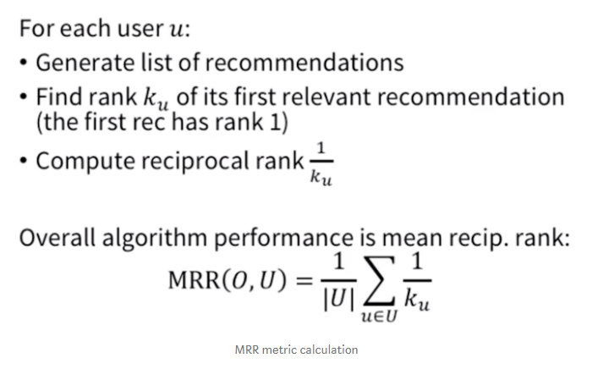

**Code Description:**

**Non- Enhanced Model:** A simple N-Gram model with no changes.

**Enhanced Model:** Two constraints are applied to the Normal N-Gram Model.

* Length Constraint- Only those word are taken in the Query whose length varies from “length of input word”+2 to “length of input word”-2 .
* Bi-grams match constraint- The maximin bigrams match query and query less than that.

**Observations made :**

1. On addition of start and end symbol in the Non-enhanced model MRR increases by a factor of two.
2. Better results in the Enhanced Model.
3. More the MRR Value better the Results

**Additional Analysis:**

Slightly better results in case of removal of punctuations